Decentralized Finance

An in-depth study for various use cases

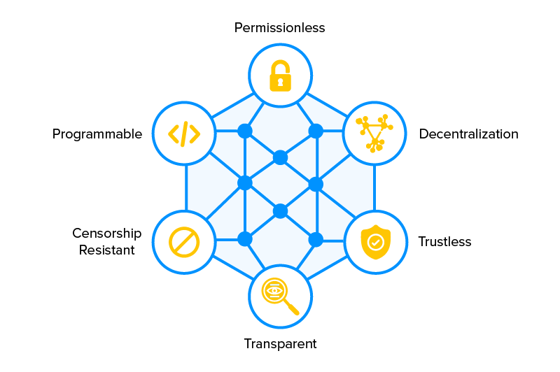

# **INTRODUCTION**

Decentralized finance offers financial instruments without relying on intermediaries such as brokerages, exchanges, or banks.

So basically, **DEFI** relies heavily on three major things -

* Cryptography
* Blockchain
* Smart contracts

It is worth mentioning that currently most DEFI projects are based upon **Ethereum**. Reason is that Ethereum’s fairly robust programming language called **Solidity** allows writing advanced smart contracts that can contain all the necessary logics for the defi applications. Obviously, there are hundred other reasons as well, to use Ethereum.

Yeah, DEFI is trying to create the whole new financial ecosystem in a permissionless and open way blah blah !!

# **Talking about 5 important pillars of Decentralized Finance -**

* **Stablecoins -** These are Cryptocurrencies where the price is designed to be pegged to a cryptocurrency, fiat money, or exchange-traded commodities. [*Read more*](https://www.businessinsider.in/investment/news/top-6-stablecoins-in-the-crypto-market-what-are-they-how-to-they-work-and-why-they-have-governments-worried/articleshow/87667452.cms).
* **Lending and Borrowing -** One sends the tokens they wish to lend into a “money market” using a smart contract, which then issues interest in the platform’s native token. [*Read more*](https://cointelegraph.com/explained/defi-lending-and-borrowing-explained).
* **Decentralized Exchanges -** These are peer-to-peer marketplaces where one makes transactions directly w/o handing over management of their funds to an intermediary or custodian with the help of smart contracts. [*Read more*](https://cointelegraph.com/defi-101/what-are-decentralized-exchanges-and-how-do-dexs-work).
* **Insurance -** Instead of buying coverage from a single person or company, you buy coverage from a decentralized pool of coverage providers. Coverage providers do so by locking capital in a so-called “capital pool”. [*Read more*](https://www.blockdata.tech/blog/general/defi-insurance-simply-explained).
* **Margin Trading -** Traders use their own funds as a guarantee, magnify their original principal by several multiples and use these magnified funds to make larger investments. The protocol manages your position a/c to market. [*Read more*](https://medium.com/imtoken/defi-explained-margin-trading-bb6b80cd072f).

Now, cutting straight to the point -

# **On and Off Ramp infrastructure in crypto -**

A cryptocurrency on-ramp refers to an exchange or similar service where you can offer fiat money in return for cryptocurrency. While off-ramp acts as a way to convert your cryptocurrency into fiat, or possibly products and services.

This process is important here as, in the defi world you first convert your money (USD or INR) into some cryptocurrency to do all sorts of things (mentioned in page 1) in the defi ecosystem, while making profit out of it and hence getting those profits cashed out into fiat money to pay your bills.

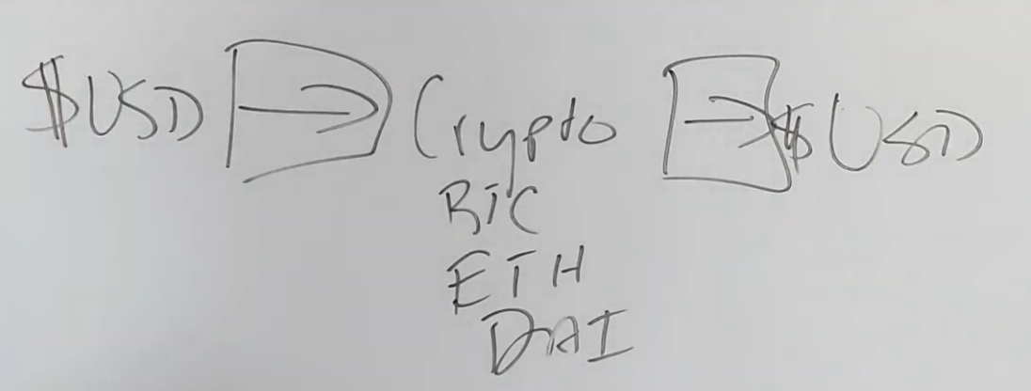

Well it wasn’t as simple as it seems. There was a whole lot of headache practicing this method as neither the banks nor the government (US and others) was supportive in the process. There used to be enormous amounts of *charge cut*, *transaction limitation*, and *delay* by these authorities initially.

So the overall problem statement is that there is too much of *fees, verification, interference* and *limitations* in both on ramp and off ramp process. [Watch this video](https://youtu.be/r3mOV8Anc3Q) to understand more about the **problem statement**.

Although, the on ramp issue can be looked after in some cases like mining, or going to p2p exchanges but the off ramp issue remains a headache.

One ideal solution could be - companies start accepting these cryptocurrencies. For eg. if we have to pay our bills, then why not the billing station accept the payment in BTC, DAI etc? In that way, we wouldn’t have to get our currency exchanged to fiat in the first place. But the point is we don’t live in an ideal world as of now. So till then, we gotta wait for that.

#### 

#### **Coming to solution -**

In the US market there are a few ways people choose to dodge this issue to some extent. So it goes like this - you buy some cryptocoins, do the stuff around the defi system and finally get those coins either converted into some stablecoins, or directly into fiat in some cases. The conversion is done using these two methods. First is using EXCHANGES like Binance etc, and the other is using the OTC market. [Read more about the two here.](https://keydifferences.com/difference-between-otc-and-exchange.html)

Then people figure out how to get those stablecoins cashed out to our bank account by looking for some favorable banks around. [Watch this video](https://youtu.be/73ftsxLoznU) to understand more about the solution.

#### 

#### **Companies Case Study -**

**Moonpay -** MoonPay claims to be a financial company that builds payment infrastructure for cryptocurrency. Think of MoonPay as a ‘PayPal’ for crypto.

If you are using MoonPay as an individual, you can:

* Buy cryptocurrencies and store it in any of the supported wallets
* Sell cryptocurrencies stored in any of the supported wallets

If you are using MoonPay as a business, you can:

* Integrate MoonPay on your platform through which users can buy and sell crypto
* Plug MoonPay in NFT marketplaces to enable complete easy transactions at the checkout.

The actual cryptocurrency that one buys through MoonPay is provided by the different exchanges and MoonPay integrates with them in order to complete the payment process for the cryptocurrency.

In this case, MoonPay is responsible for the risk assessment of the customer and the transaction, processing the payment from the credit card company or Apple Pay or Google Pay and ensuring the transaction is successful. The core of MoonPay is a special AI technology that enables these transactions with highly quick and accurate risk assessment.

They have their integrated KYC process with bank details and statements verification and stuff together. Although they have this rule that users can buy or sell upto some limit without proper KYC too. And with KYC, they allow users to do bigger transactions and all.

INSIGHT - Interesting thing I could see as Indian using it was that - people here be buying a cryptocurrency worth of some money which has the least gas and transaction fee on Moonpay, then go on some exchange platform to get that (low fees) coin into a nice useful coin with very less conversion fee and then use it for their purposes and do vice versa when necessary.

**Wyre** - Wyre also is not just a ‘fiat-to-crypto gateway’, or ‘fiat onramp’, but rather a payment service provider that also does fiat-to-crypto conversions. The company provides an API and widget.

Third parties can implement Wyre’s fiat gateway widget on their websites, wallets and exchanges to allow their customers to buy cryptocurrency directly using various fiat currencies. This has the advantage that developers don’t have to worry about KYC/AML compliance, while user-onboarding for crypto-related applications is improved as users don’t have to first go to a third-party exchange.

So in both B2B or B2C solutions, wyre has a strong KYC check on their platform before using. Though the number of crypto and stablecoin options are less in wyre as compared to its competitors.

INSIGHT - Processing and transaction fee in wyre (for same coins) is a little less than that of Moonpay or Simplex. So, the users get a bit more savings on their purchase.

# **Market Maker / Liquidity Pool -**

There are 2 types of DEX’es based on how they provide liquidity -

1. **Order-book based -**

These operate similarly to CEXs. Users can set buy and sell orders at limit or market prices.

Decentralised and Non custodial, ie. assets are stored in user's wallet e.g. dYdX.

1. **Liquidity pool based -**

Lets users become the market makers by providing liquidity to a pair or pool of assets.

Mainly use an Automated Market Maker mechanism. e.g. Uniswap.

#### 

#### **Coming to steps one by one -**

**Automated Market Maker (AMM) -** An automated market maker (AMM) is a tool used to provide liquidity in decentralized finance (DeFi). They are used to enable the automatic trading of digital assets.

These protocols use smart contracts to define the price of digital assets and provide liquidity. In essence, users are not technically trading against counterparties – instead, they are trading against the liquidity locked inside smart contracts. These smart contracts are often called liquidity pools (more on this, later).

There are two important things to know first about AMMs:

* Trading pairs you would normally find on a centralized exchange exist as individual “liquidity pools” in AMMs. For example, if you wanted to trade Ether (ethereum's native currency) for Tether (ethereum token pegged to the US dollar), you would need to find an ETH/USDT liquidity pool.
* Instead of using dedicated market makers, anyone can provide liquidity to these pools by depositing both assets represented in the pool. For example, if you wanted to become a liquidity provider for an ETH/USDT pool, you’d need to deposit a certain predetermined ratio of ETH *and* USDT.

This is an algorithm that determines what happens when. [Read more about it here.](https://www.coindesk.com/learn/2021/08/20/what-is-an-automated-market-maker/)

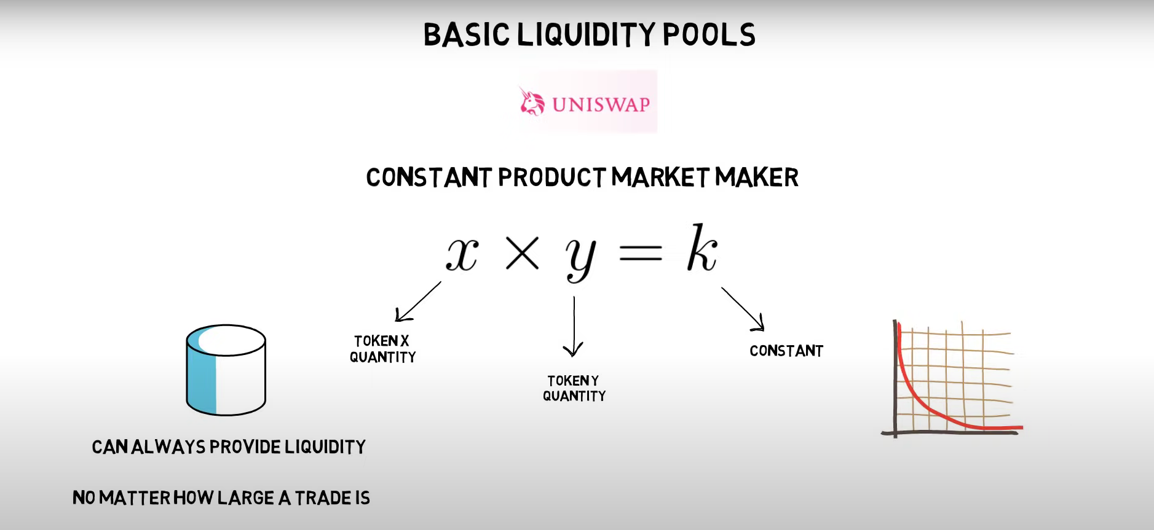

**Liquidity Pool -** A liquidity pool refers to a pool of tokens that are locked in a smart contract, which is a self-executing program based on the agreements between the buyer and seller.

The pool is the place where investors, or in this case “liquidity providers” (LPs), add equal values of stablecoins and the cryptocurrency’s coins while LPs provide a service to DEX buyers and sellers by equipping them with tokens that are easily tradable within the same blockchain.

Furthermore, liquidity providers (LPs) are necessary to initiate trading in an environment where there is no seller. That is to say that, if people want to buy certain coins but nobody wants to sell, the LPs don the hat of the seller.

In exchange for adding tokens into the pool, LPs receive interest in the form of trading fees from the trades people make within the pool. This is also known as liquidity mining.

A simple diagram on how it works. [Read more about it here.](https://komodoplatform.com/en/academy/liquidity-pools/)

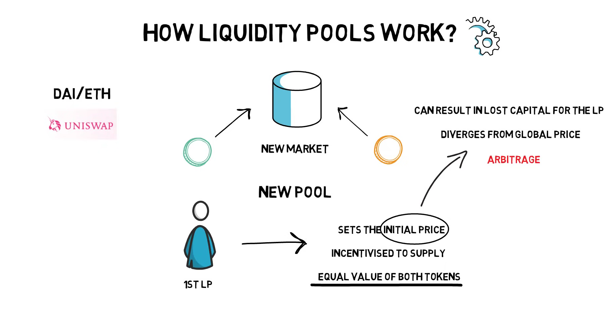

#### **Companies Case Study -**

**Uniswap** - Uniswap is an Automated Market Maker (AMM). It allows users to swap any ERC20 token, using the liquidity pool instead of the order book. But it has a disadvantage such as a slippage when the market fluctuates strongly and a lack of liquidity on one-side occurs. Besides, Uniswap has some risks such as front running, token risk, smart contract risk and impermanent loss.

Uniswap is a 100% decentralized and permissionless protocol, operating on the following formula: x * y = k (called “constant product”).

For example, if you contributed $10,000 to a liquidity pool that held $100,000 in total, you would receive a token for 10% of that pool. This token can be redeemed for a share of the trading fees. Uniswap charges users a flat 0.30% fee for every trade that takes place on the platform and automatically sends it to a liquidity reserve.

Whenever a liquidity provider decides they want to exit, they receive a portion of the total fees from the reserve relative to their staked amount in that pool. The token they received which keeps a record of what stake they’re owed is then destroyed.

After the Uniswap v.2 upgrade, a new protocol fee was introduced that can be turned on or off via a community vote and essentially sends 0.05% of every 0.30% trading fee to a Uniswap fund to finance future development. Currently, this fee option is turned off, however, if it ever turned on it means LPs will start receiving 0.25% of pool trading fees.

Getting started with Uniswap is relatively straightforward, however, you will need to make sure you already have an ERC-20 supported wallet setup such as MetaMask, WalletConnect, Coinbase wallet, Portis, or Fortmatic.

Once you have one of those wallets, you need to add ether to it in order to trade on Uniswap and pay for gas – this is what Ethereum transaction fees are called. Gas payments vary in price depending on how many people are using the network. Most ERC-20 compatible wallet services give you three choices when making a payment over the Ethereum blockchain: slow, medium or fast. Slow is the cheapest option, fast is the most expensive and medium is somewhere in between. This determines how quickly your transaction is processed by Ethereum network miners.

**PancakeSwap** - It is a decentralized exchange (DEX) on Binance Smart Chain (BSC) and is designed to allow users to securely trade Binance Coin (BNB) and a massive variety of BEP-20 tokens.

Similar to Uniswap, PancakeSwap is generally accessed through a supported Web3 wallet, such as MetaMask, TrustWallet, or WalletConnect. Once configured to support Binance Smart Chain, these wallets are used to interact with the PancakeSwap smart contracts via the intuitive PancakeSwap front-end.

In February 2021 PancakeSwap surpassed Uniswap as the largest automated market maker-based exchange. However, PancakeSwap couldn’t last long in the position and was soon overtaken by Uniswap in September 2021. Though, despite overtaking PancakeSwap, Uniswap still is in the second position in the list of top DEXs with the list being led by Biswap.

PancakeSwap upgraded to V2 in April 2021, giving the developers more freedom to improve the future functionality of the platform — such as auto-compounding in syrup pools and adding a referral program. This was subsequently followed by a change in the fee schedule (from 0.2% to 0.25%) with 0.05% of this used to buy CAKE from the public market before burning it to add another deflationary mechanic to the token.

**WazirX** - In India, WazirX has tried its hands on being AMM but hasn’t been very successful. (not much information is there. yet to figure it out about it)

# **Custodian Service in Defi -**

The money in our bank account doesn’t actually belong to us. Even though our bank account has our name on it, that money technically belongs to that bank and they’re often allowed to do whatever they want with it, behind the scenes.

By contrast when we hold a cryptocurrency in our wallet, those coins or tokens are ours and nobody can do anything with ‘em behind the scenes w/o the permission of our “private key”. Now the ability to self-custody is one of the primary reasons why cryptocurrencies have value.

Every cryptocurrency wallet consists of two things -

* Public key - used to create publicly viewable crypto wallet addresses. These are the jumbles and letters you send crypto coins or tokens to.
* Private key - are not publicly viewable and it’s used to send coins and tokens out of any crypto wallet addresses created by the associated public key.

#### 

#### **Coming to solution -**

There are three types of custody - self, joint and third-party. Our point of discussion is third-party crypto custody. This is when someone else holds the private key to your cryptocurrency wallet.

The third party custody falls into two categories -

* **Informal** - These custodians are individuals or institutions you can hold your crypto with even though custody isn’t their shtick. Example can be a centralized cryptocurrency exchange. When our coins and tokens are on an exchange, they technically don’t belong to us in the same way that the money in our bank doesn't belong to us. That crypto might show up under our name but it actually belongs to the exchange. The only difference b/w banks and exchanges is that exchanges don’t typically lend out or trade our crypto behind the scenes unlike banks.

Even so there are massive risks associated with holding one's crypto on an exchange. The likes of exchange hacks are quite common because the high concentration of crypto in one place makes hacking and exchange an extremely lucrative operation. Exchange hacks are possible because basically all the wallets you use on an exchange are hot wallets (that are constantly connected to the internet). The fact that exchanges are centrally operated by corruptible humans also means that the exchange operators themselves could just as easily run off with one’s crypto anytime. This has already happened in some parts of the world.

* **Formal** - These are built from the ground up to offer the best in class security, clystar clear security, lots of liability and even insurance. Although, most of the largest formal third-party crypto custodians are subsidiaries of crypto exchanges such as Coinbase Custody and Binance Custody.

Some projects also offer formal third-party custody such as BitGo, Paxos, Gemini, etc.

#### **Companies Case Study -**

**BitGo** - BitGo enables clients to navigate the complex landscape of digital assets with a connected, compliant, and secure suite of solutions. No matter what exchanges, OTC desks, or brokers you use for trade or what custodial services or wallets you use for custody, BitGo ingests and resolves your present and historical transactions automatically to unlock holistic views across performance, positions, and tax.

It basically issues wrapped bitcoin in ethereum.

Customers - *CoinDCX*, *Zebpay*, *Vauld*, *Pillow*, etc.

**Paxos** - Custody is also a service in which a financial institution holds assets on behalf of the client. Paxos custodies both crypto assets like Bitcoin, physical assets like gold and other assets like securities. It issues stable coins such as USDP, BUSD and Pax-G.

**Anchorage** - It is a regulated platform that provides both prime services such as custody, lending, and trading, as well as infrastructure, which companies can use to build cryptocurrency products.

# **High Yield-**

High returns in defi is often called high yield generation. So, there are different ways companies try to pull off high yields & cumulative of these ways is called *Yield Farming*.

Let’s dig into it first. **Yield Farming** is a process of putting your cryptocurrency in the most optimized spot so that it’ll earn you even more cryptocurrency.

It has four basic methods that’ll give you highest returns -

* **Liquidity Providers** - Investors can supply coins and tokens to a decentralized exchange. In return these exchanges take a very small fee of all the trades happening on the platform and they give that back to the investors. If there are a ton of trades happening and this investor is one of the few investors, they can earn a very high return on their investment. Platforms can be - *Uniswap, PancakeSwap, QuickSwap,* etc.
* **Borrowing and Lending** - There are a few ways one earns income through this. Let’s see them -
  + Lending - Many borrowing and lending services will provide rewards to those who will lend their crypto to the platform. For example - Compound and Aave lending rates (for specific coins) goes upto 30% APR.
  + Borrowing - Imagine if one has some Ethereum lying around and he wanted to take out a loan but didn’t wanna cash out the Ethereum because he thought it’s going to go up in price. At the same time he believed in an Ethereum project so he could borrow some DAI coins and mock up Ethereum as collateral. (Will come to this later). Later when he pays back the DAI and gets the initial Ethereum deposit, the value of those Eth might have gone up by then.
  + Leveraged Lending - Basically one lends their money on platforms like Compound and Aave and takes what they can borrow and then just reinvest it. For example - If one deposits a $100 worth of some token, these platforms allow them to borrow $60 in DAI from it. Now they take that $60 worth of DAI they have, convert it back to that same token (in a DeX), and get $60 worth of that token and they resupply it back to Compound or Aave (earning extra APR) and it keeps on going only.
* **Staking** - It is a form of yield farming as one can buy coins, stake them and earn more free coins. For example -
  + Tezos - If staked through platforms like Coinbase, it gives around 6% APR.
  + Ethereum 2.O - It is moving from “proof of work” to “proof of stake” which means instead of a bunch of miners doing a ton of work to mine Ethereum, the code is changing so that one miner at a time will earn that Ethereum and validate those blocks. So one can participate and get rewarded here.
  + LP Tokens - These are tokens that one gets when providing liquidity. And many platforms allow people to take these tokens so that they can earn interest on them.

INSIGHT - Both **APR** and **APY** measure interest. But APR is used to measure interest required to pay, while APY is used to measure the interest earned.

#### **Coming to Indian context -**

PREFACE - Not many people have a fair idea whatsoever about how such Indian platforms are giving this much consistent high return. Most of it is still just speculation.

What it appears to be is that they might be yield farming “manually”. They’d put those coins into a high yielding liquidity pool giving them higher returns through which they'd take their cut (%) and return the majority of it to their customers. Also, they’d allot some percentage to something called as “reserves” so that whenever the market collapses (temporarily) or they’re not able to make those high returns (for some reason), they’ll have a backup in the form of those reserves.

Also, these companies invest capital into some blue-chip Defi protocols to earn such yields. They’ve a research team which is actively monitoring 100s of protocols to find the safest ones to invest in. The likes of Aave, Uniswap, Compound, Maker, etc are some examples of the blue-chip protocols.

[A nice Twitter discussion on the same](https://twitter.com/championswimmer/status/1493908985652543491?t=uHEOuBo8cMRU50rDFnXo3A&s=19)

#### 

#### **Companies Case Study -**

–---------------------------------------------------------------------------------------------------------------------------------------

**Layer 2 Solutions-**

Scalability is one of the main concerns in Ethereum blockchain development. A scalable blockchain can handle thousands of transactions simultaneously.

Due to the high number of dApps and use-cases built on top of Ethereum, we often experience a high level of network activity. This indeed causes network congestion and extremely high gas fees. Therefore, the Ethereum blockchain needs scaling solutions.

Although, ETH 2.0 addresses part of the scalability-related issues mainly by introducing sharding and docking mechanisms (more on this, later). However, to achieve higher levels of scalability, we need to have layer 2 scaling solutions.

Layer 2 scaling is a collective term for solutions that help with increasing the capabilities of layer 1 by handling the transactions off-chain.

INSIGHT - There could be two ways to scale. Scale the **Base Layer** or **Outsource Work To New Layer**. But we cannot scale the BASE LAYER because of **The Blockchain Trilemma**.

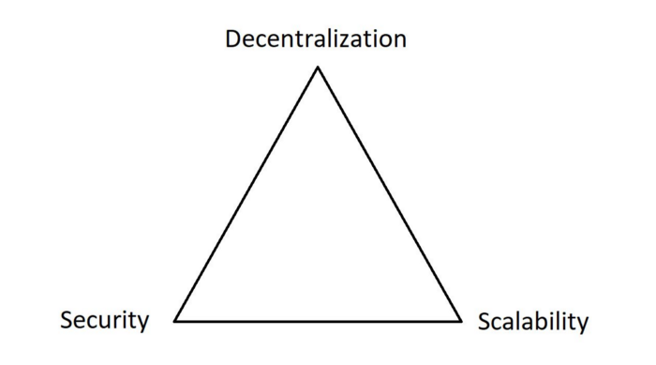

Developers haven’t found a way to maximize all three. If they try to improve one, the other two start to lose their benefits. So, the only option left is to outsource the work to a new layer on top of the existing one.

#### 

#### **Layer 1 vs Layer 2 -**

**L1** - Scaling the base layer itself is called layer 1. It is a standard base consensus layer where pretty much all transactions were settled earlier.

In this layer, Ethereum could only process around 15 transactions/sec.

**L2** - Scaling the network by offloading some of the work to another layer is called layer 2. It is another layer built on top of layer 1. It has the following characteristics -

* It doesn't require any changes in layer 1. It can be just built on top of layer 1 using its existing elements such as smart contracts.
* It also leverages the security of layer 1 by anchoring its state into layer 1.
* It can dramatically increase the number of transactions depending on the solution (around processing 2000-4000 transactions/sec).

Types of layer 2 scaling mechanisms -

1. **Rollups** - They perform transaction execution outside the main Ethereum blockchain and send the transaction data back to the main Ethereum network.
   1. **ZK Rollups** - They are very efficient rollups that combine a bunch of things that you want to do on the blockchain into one rolled up thing. However, they can’t use smart contracts.
   2. **Optimistic Rollups** - They have their own optimistic virtual machine which allows them to do stuff with smart contracts but they’re slower and less efficient.
2. **Sidechains** - They are secondary blockchains that would run parallel to the side of a main chain and use the resources they have to offload the work. They can steal or borrow information from the main blockchain and use their virtual machine to execute smart contracts or validate transactions and then send the data that they have back to the main blockchain for security reasons.

A side chain cannot operate without its parent chain but a parent chain does not need a side chain. POLYGON is a good example of a sidechain. (Coming on this).

1. **Plasma** - Plasma uses sidechains (also known as plasma chains) which have their own child chain that they can broadcast important operations to the main chain.
2. **Channels** - Channels are a way to lock up your funds and then trade a virtual version of your funds on a network that is much faster. In a channel system, we simply use code to make sure you can only send what you have actually locked up. Eg - The Lighting Network.

Insight - They can only be used for transactions not for smart contracts, etc.

[Read more about these solutions here.](https://www.quicknode.com/guides/infrastructure/introduction-to-ethereum-rollups) [Or here (Official docs).](https://ethereum.org/en/developers/docs/scaling/)

#### 

#### **Notable Layer 2 Solutions -**

**Polygon -** Polygon, formerly known as Matic Network, is a Layer-2 blockchain scalability platform and framework for connecting and building blockchain networks compatible with Ethereum.

The Polygon network is Ethereum-native, aligned to be interoperable with all of Ethereum’s existing and even future infrastructures while offering a framework for its interoperability with other layer-2 solutions, sidechains and sovereign blockchains.

The network currently hosts over 7000+ dApps, of which over 150 big names migrated from the ethereum main chain. Since Polygon is so similar to Ethereum, many developers that develop useful tools will actually move them from Ethereum to other EVM blockchains like Polygon. That way they can increase their reach and usage. Since it runs basically all the same code, it makes sense how developers can simply move their project over to a new network and it’ll work basically the same way w/o making many changes.

Technically, Polygon is a lot more than just a side chain. One of the core ideas behind Polygon is to equip developers with user-friendly and flexible tools. That way they can fast track Ethereum’s transformation into a multi-chain platform i.e. Polygon isn’t just a single proof of the stake chain that we usually think of. They’re a series of blockchains that can help scale Ethereum.

How does it work - Polygon is driven by the layer-2 scaling solution and the proof of stake protocol serving as what’s called a “commit chain” (which functions as a transaction network that operates close to the real chain) to the main Ethereum chain. The Polygon commit chain groups up clusters of transactions and processes them altogether before sending the data back to the main Ethereum chain. For eg - *what they’re doing is taking some part of The Blockchain Trilemma say scalability and security and trading off a bit of decentralization (not completely) but then they’re able to compute at much faster and are secure.*

A good in-depth read on everything about Polygon (Matic) - [Read Here](https://forkast.news/what-is-polygon-matic-ethereums-internet-blockchains/).

A nice video conversation with YourStory on the same - [Watch here](https://youtu.be/dOQmkVNFo7g?t=38).

Its Architecture - Polygon’s Architecture runs on a 4 Layer system comprising of -

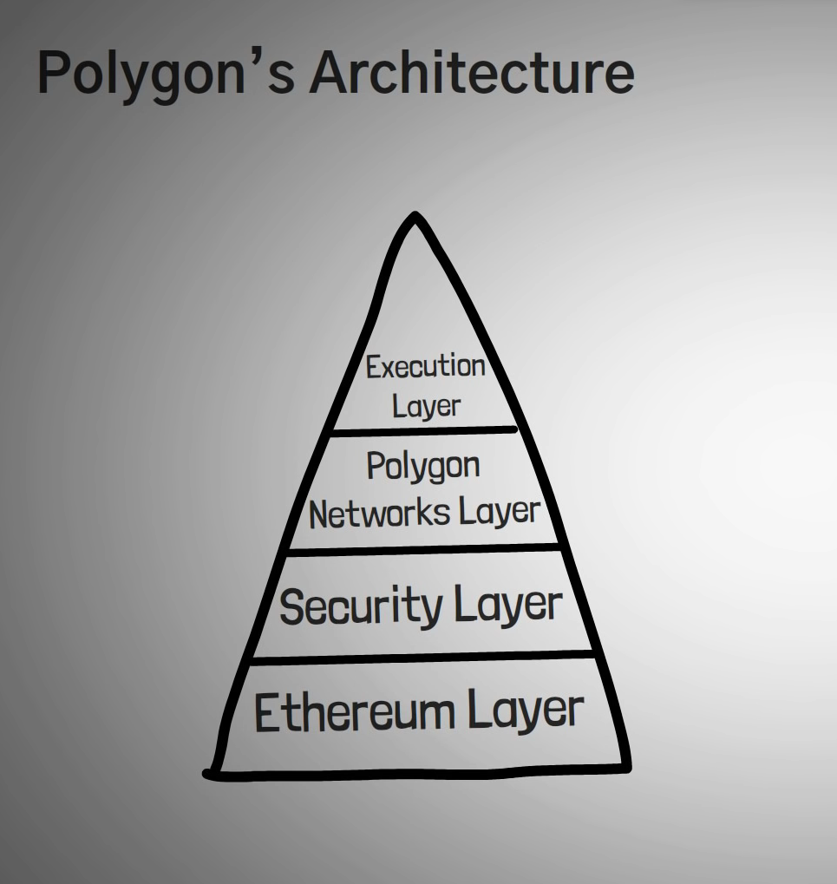

Some Big Companies using Polygon -

|  |  |  |
| --- | --- | --- |
| Aave | QuickSwap | SushiSwap |
| Decentraland | Polymarket | Atari |
| Curve Finance | EasyFi | 1inch |
| Metamask | Gas Station Network | Coinbase |
| TrustWallet | Ledger | Moonpay |
| Wyre | Chainlink | Binance DeX |

*“...further update will be in the evening****…****”*

### Introduction

1. What is Product Management
2. Why product management is important
3. History and Evolution of Product Management

### Role of Product Manager

1. Purpose of Product Management
2. Product Managers Roles and Responsibilities
3. Types of Product Managers

### Product Manager Vs…

1. Product Manager vs Product owner
2. Product Manager vs project manager
3. Product Manager vs Product Leader
4. Product Manager vs Business Analyst

### Product Vision

1. What is a product vision?
2. Difference between Vision & Mission
3. Product vision exercise
4. Jeff Bezos: Vision of Amazon
5. How to Demonstrate Product Vision in a PM Interview

### Product Strategy

1. What is a Product Strategy?
2. Getting product strategy right
3. OKRs
4. OGSMs
5. Outcome & Measures

### Product Team

1. What is a product team?
2. Building a team
3. Empowered product teams
4. Balance teams
5. Feature team vs Product Teams

### Product Discovery

1. Introduction to Product Discovery
2. Product Discovery Team & Roles
3. Product Discovery Process
4. What is a Problem Statement?
5. How might we statement builder

### User Research

1. What is user research
2. Qualitative vs Quantitative research
3. What research methods
4. How to talk to your users
5. 3 Types of User interviews

### Research Synthesis

1. Create User Personas
2. How to create an empathy map
3. Journey Maps
4. Stakeholder mapping
5. Persona vs Jobs to be done

### Experimentation

1. Lean Experiments
2. Plan your experiments
3. What is product Roadmap
4. Now near next
5. Outcome based roadmap

### MVP & Metrics

1. What is an MVP
2. Lean MVPs
3. Only Metric that Matters
4. How to Measure your product
5. Common Business Metrics

### BDD & User Stories

1. What is Business driven development
2. BDD Vs Traditional Development
3. User Stories
4. Agile User Story Mapping
5. Given, When, Then